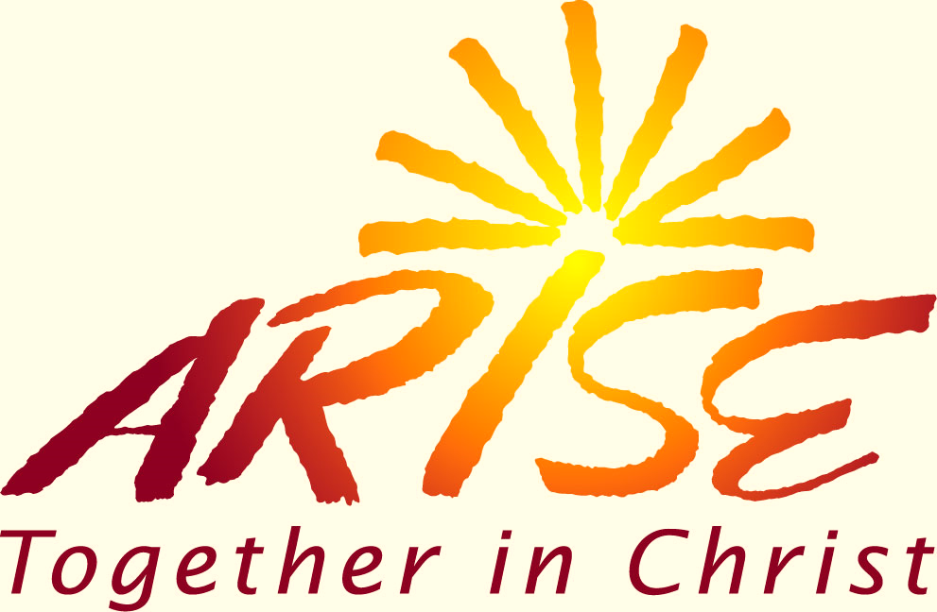

**Parish Arise! Teams, Small Community Leaders and All Participants**

Join us for the  
*Arise Together in Christ*

Commissioning Liturgy  
Celebrated by Bishop Mark Bartchak

**7:00 p.m., Sunday, August 18**

**Shrine of Our Lady of the Alleghenies**

(adjacent to the Basilica of St. Michael  
the Archangel, Loretto)

***Remember your lawn chairs.***

**Please sign up online at**: www.dioceseaj.org/arise